Code = sketch.ino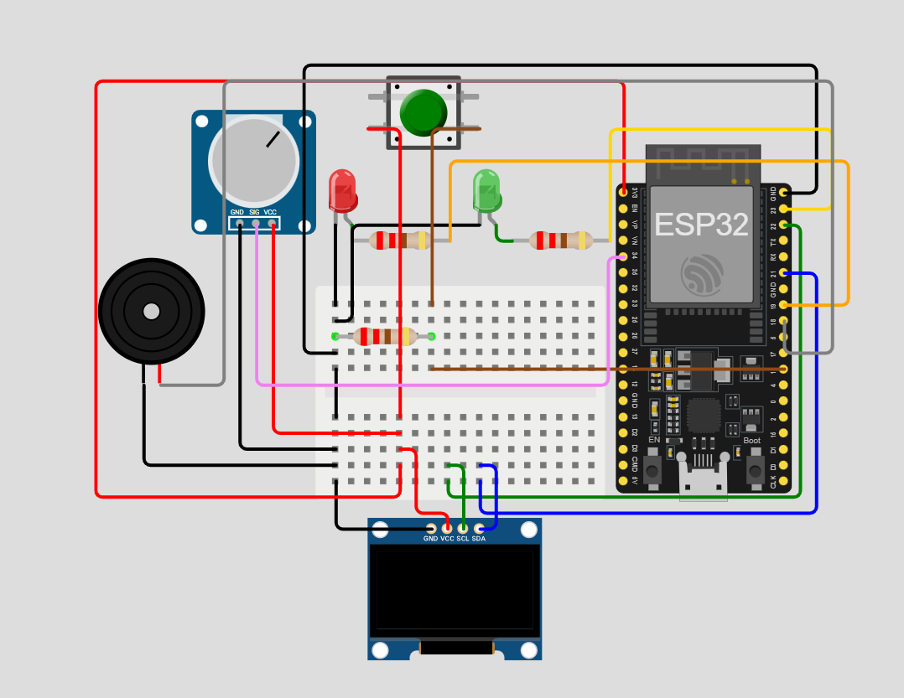

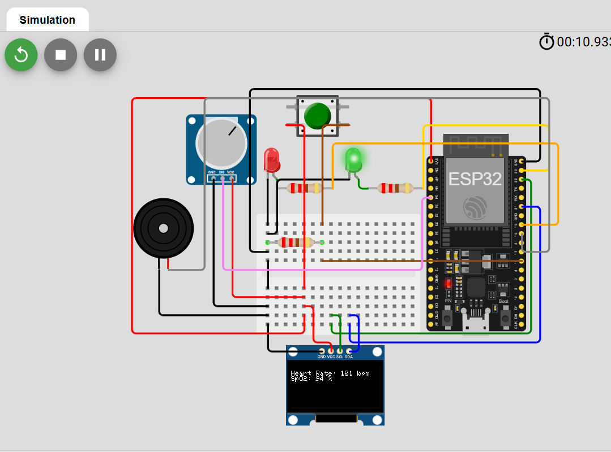when Heart Rate and SpO2 is normal, the Green LED is ON

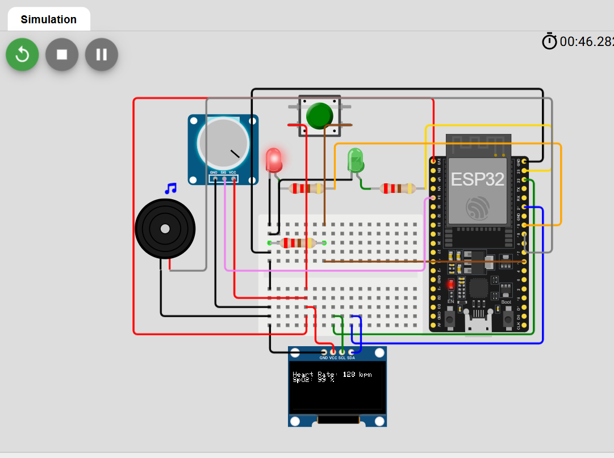When the Heart Rate and SpO2 is abnormal, The Red LED and Buzzer is turned ON

Using Real Components

CODE = MAX30100.cpp